TO ALL OVG360 Employees - INTRODUCING……
ADP - EMPLOYEE SELF SERVICE (ESS)

We are excited to inform you that OVG360 has rolled out ADP’s Employee Self Service (ESS) for all of its venues. You will now be required to enter any address, direct deposit, and W4 changes directly through ADP. Local tax changes will be handled by the corporate payroll department once they are notified of an address change. Please continue to provide the
PPG Paints Arena Payroll Department with paper copies of any changes made for their records.

Employees can log into www.myadp.com with their existing ADP username and password and follow the instructions on the attached ESS Employee Guide to make a change.

If you do not have a username and password, the ESS guide also provides instructions on how to create one. If you have trouble creating an account, please reach out to the OVG360 IT helpdesk: helpdesk@oakviewgroup.com

Please take the time to review this information carefully and set up your account today!

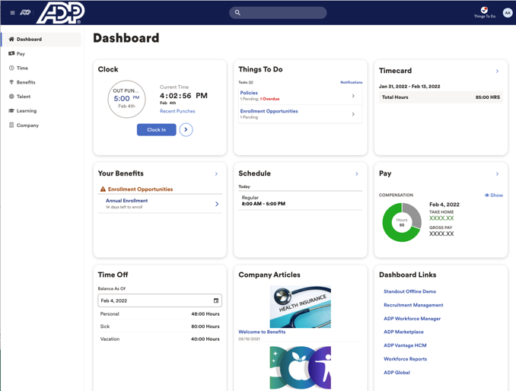
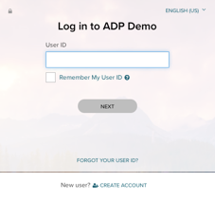
Employee Reference
for MyADP
Learn about employee-specific features
ADP, the ADP logo and Always Designing for People are trademarks of ADP, Inc. Copyright © 2021 ADP, Inc. All rights reserved. v2022.41
Self-Registration for First Time Users
If this is your first time using ADP services, follow the self-registration process below. Otherwise, use your existing ADP user ID: name@OVGLLC and password to log into myadp.com.
- Go to: NetSecure.adp.com
- Click: CREATE ACCOUNT
- Select: I HAVE A REGISTRATION CODE – code is: OVGLLC-1234
- Follow the prompts to complete your registration.

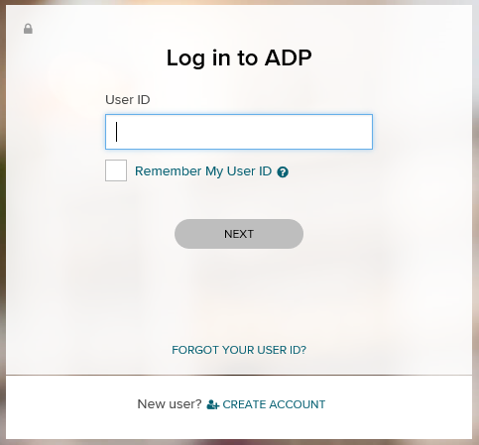
Forgot User ID
- Click Forgot Your User ID?
- Enter your First Name, Last Name, and follow instructions.
- Click Next.

Signing In
- Go to: MYADP.com
- Enter your User ID and your Password that you set up when you completed self-registration.
- Click Sign In.

Forgot Password
- Click Forgot Your Password?
- Enter your email or phone number.
- Click Next.

For further assistance in creating your account, contact the IT Help Desk: HelpDesk@oakviewgroup.com
Welcome to MyADP: Managing Your Data and Information

Now you have one central location to access and update personal, banking, and Federal tax information. From the Dashboard page you can update your personal information by clicking on “Your Profile.”

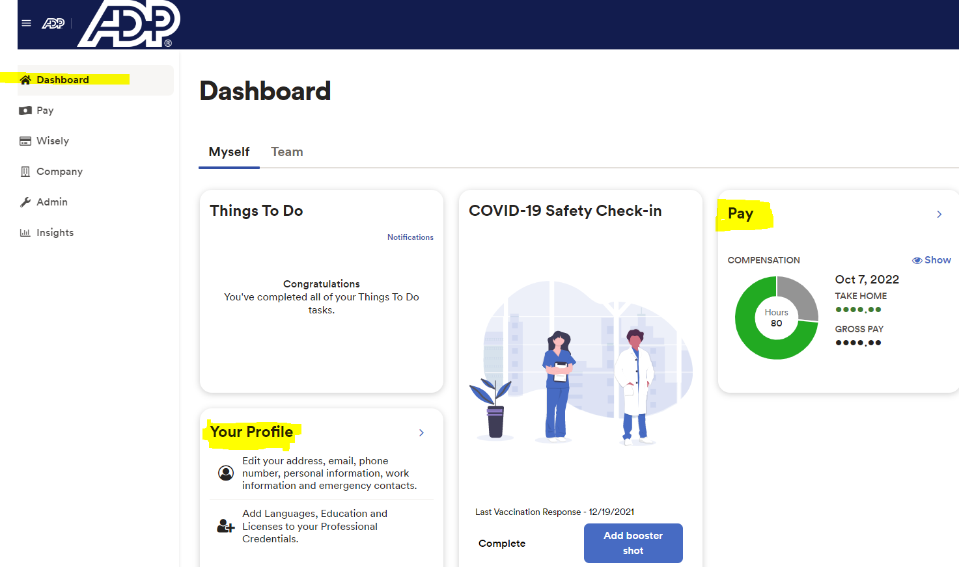

Profile
Depending on your access permissions, you may not see all the tiles on this page.
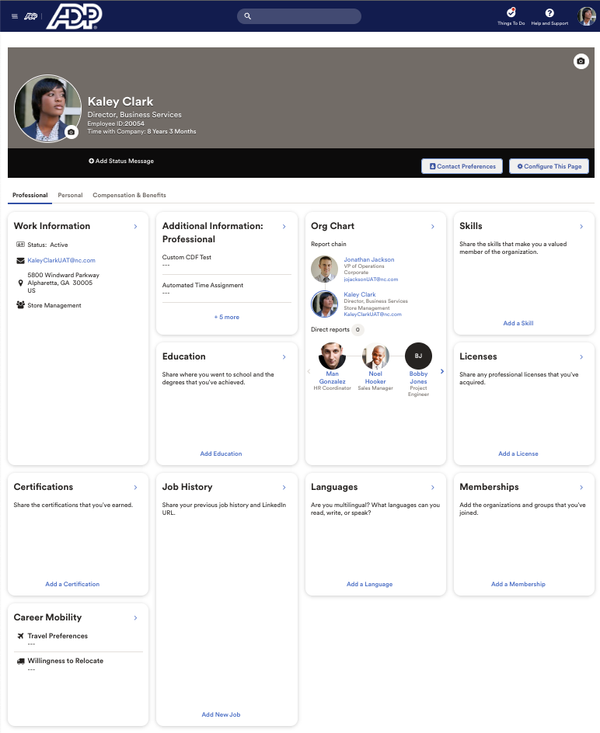
The Profile page allows you to view/update personal and work information, emergency contacts, skills, memberships, licenses, education, and more. You can customize your page with personal photos, messages about what you like do and what is important to you.

Payroll Information
The Pay page provides quick, summarized access to all your pay-related information. You can view up to three years of your pay information and W-2s. From the Pay page you can update your banking and Federal Tax information. You cannot update your state tax information at this time. Please contact your local office manager to update your state tax information.
(1) Current Pay Information
(2) Pay History
(4) Access to Tax Withholding and Tax Statements
(3) Access to Direct Deposit
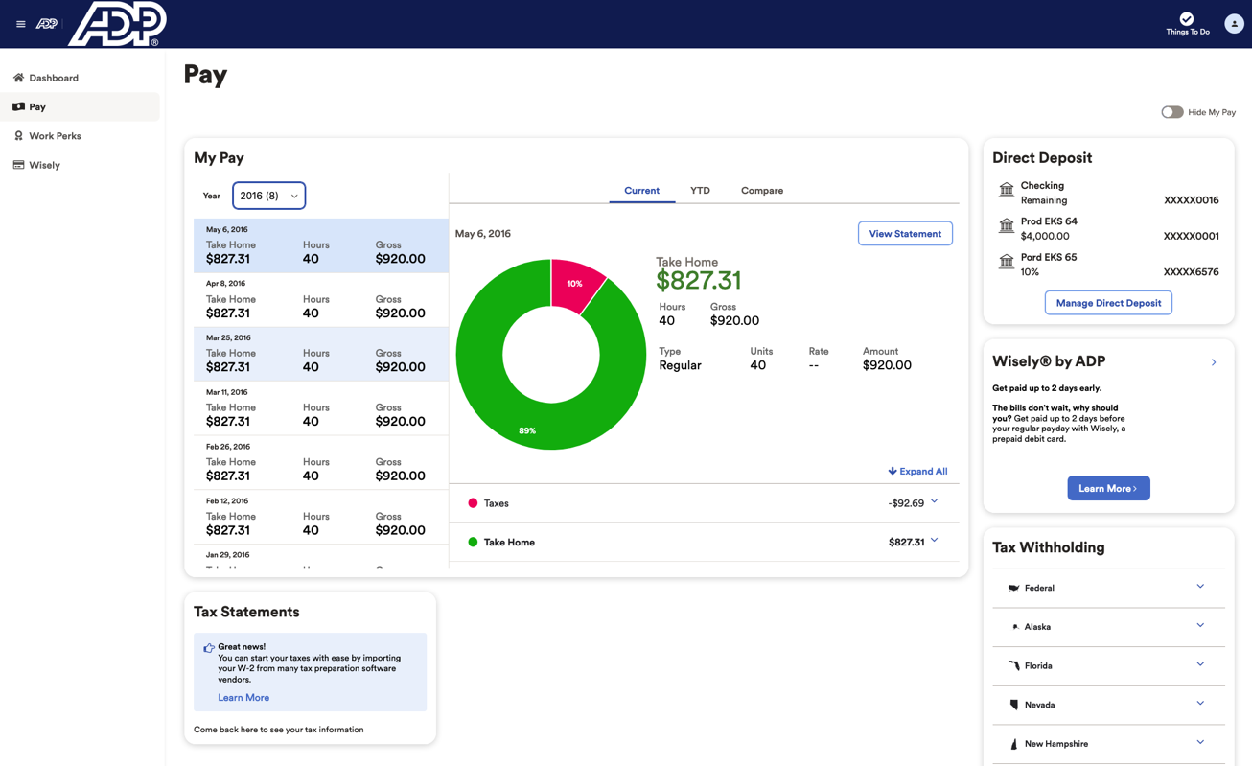

FEDERAL INCOME TAX WITHHOLDING
Tax Withholding allows you to manage your federal income tax withholding. You can generate electronically signed, fully compliant withholding certificates (W-4s), and since taxes can sometimes be overwhelming, there is a guided experience with a conversational tone that combines extensive contextual help including tips, info messages, and links out to additional jurisdiction resources including secondary forms.

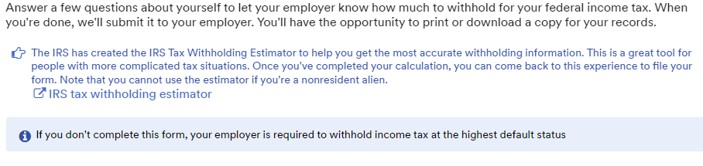

Direct Deposit
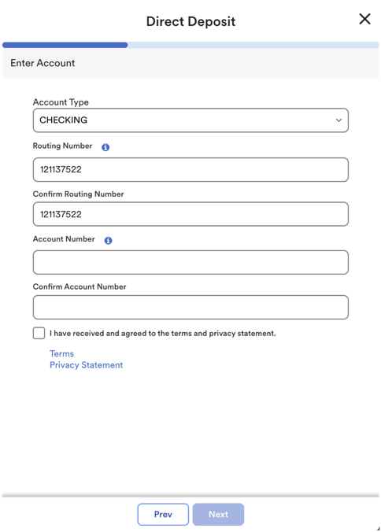
Direct Deposit allows you to manage all your direct deposit accounts. In most cases, account information is validated in real time to ensure accuracy to get your money to your accounts as fast as possible.

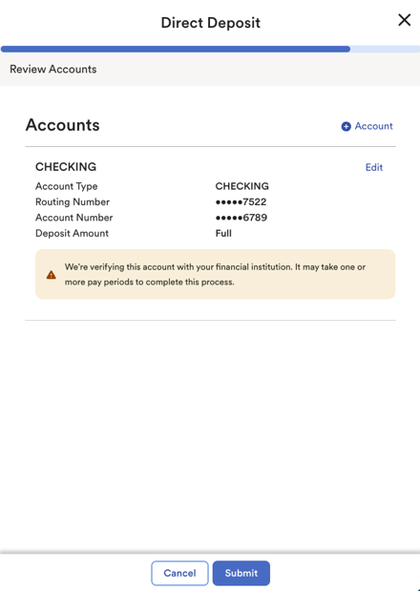
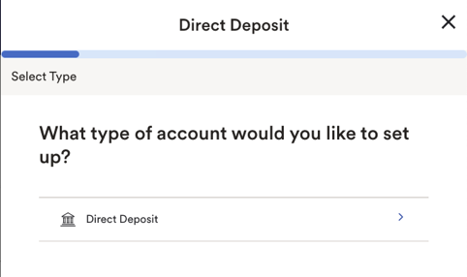
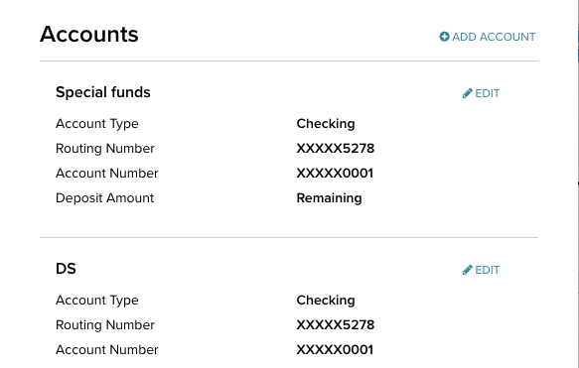
(4) Select how much should be deposited in the account

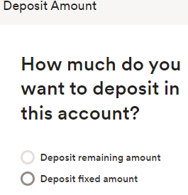
(5) Click Submit to finish
(3) Enter your account details
(2) Select the type of account
(1) Click to add account

