PPG Paints Arena Event Staff Parking

Daily non-PPG ticketed event days
Where do I park on non-event days?
- Parking is available for PPG Paints Arena and Aramark Part Time staff at Melody Tent A Lot located at 1413 Centre Ave.
How do I pay?
- Parking staff is onsite to collect payment. Credit Card ONLY! NO CASH will be accepted.
What if the lot is not staffed when I enter?
- Please scan the QR code to enter your license plate information.
How do I enter my license plate on non- event days?
- Go to https://www.offstreet.io/location/R1HORO1A
Or scan
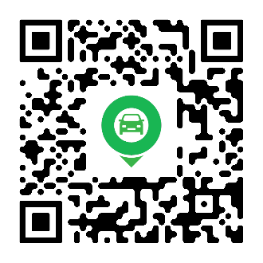
Why do I need to enter my license plate?
- Entering your license plate in the system validates your license plate as compliant in the system.
What happens if I don’t enter my license plate?
- Failing to enter your license plate will result in a notice mailed to the address the vehicle is registered to.
Do I need to enter my license plate every time I park?
- Yes, you are required to enter your license plate every time you park.

PPG Arena Ticketed Events
Where do I park on event days?
- Parking is available for PPG Paints Arena and Aramark part time staff at Melody Tent Lot A located at 1413 Centre Ave and Melody Tent Lot C located at 1250 Bedford Ave.
How do I pay?
- Parking staff is onsite to collect payment. Credit Card ONLY! NO CASH will be accepted.
Do I need to enter my License plate on event days?
- If you are parking after 12pm on events days, you are NOT required to enter your license plate. If you are parking before 12pm on event days you are required to enter your license plate.
What happens if I choose to park at a different parking lot?
- If you choose to park at a different parking lot you will be required to pay the posted rate, please scan the QR code on the signs posted at the lots to pay.
What happens if I don’t pay for parking?
- If you choose not to pay for parking, you will be issued a notice via mail to address the vehicle is registered to. The cost of a violation is $88.
Questions?
- Please contact ovg360-parklowerhill@oakviewgroup.com
